**LAB 11**

**Installing and setup Ansible Server and Nodes**

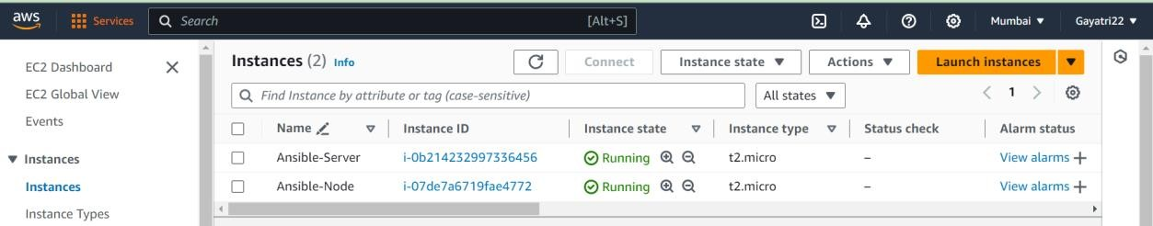**STEP 1: Create 2 AWS linux EC2 instances.**

**STEP 2: Install ansible in Server machine.**

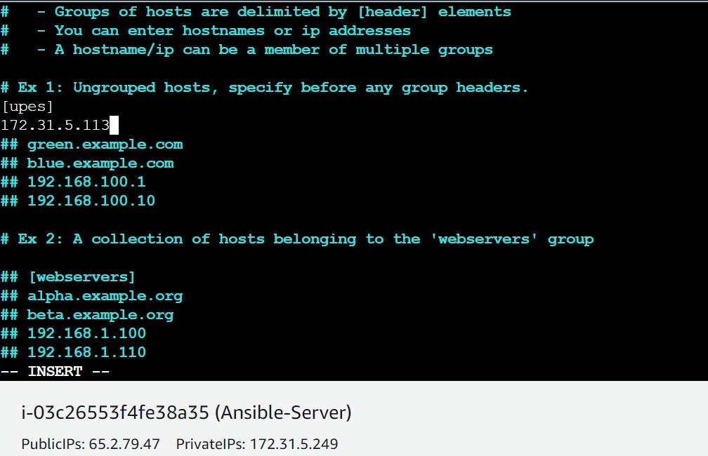**STEP 3: Add private ip of Node machine in list of known hosts in /etc/ansible/hosts file.**

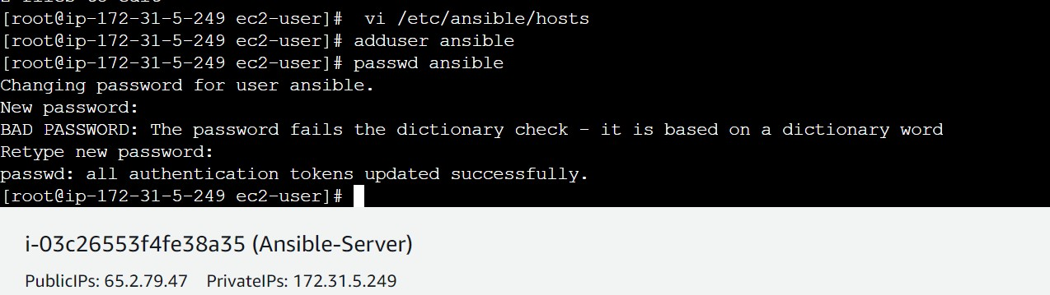**STEP 4: add user ansible in both server and node machine.**

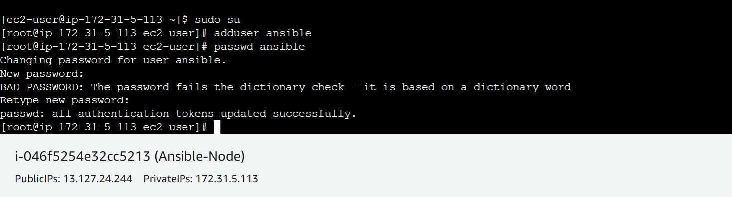

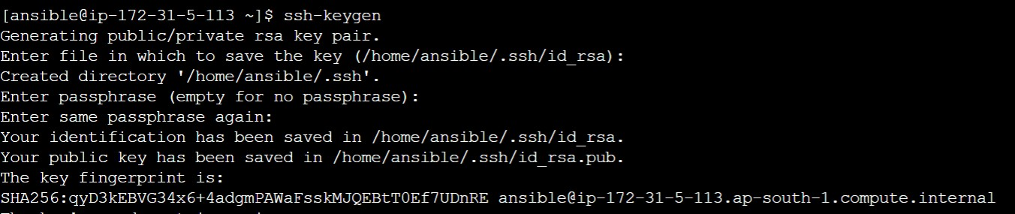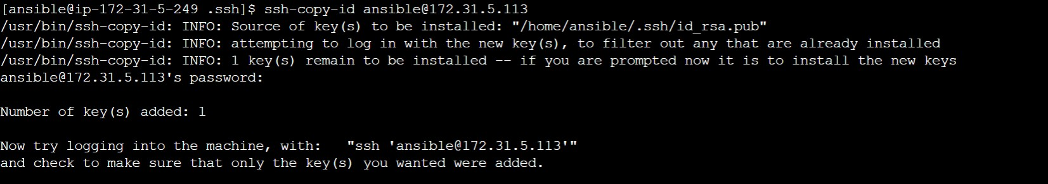**STEP 5: We have to generate a key pair and copy that into node machine.**

**STEP 6: y has been successfully added, now we can go into node machine through server only by ssh-ing into its private IP.**

